Lab Plan – 10 & 11: Text Fields, Navigation and Weather App using weather api
Task 1: Create a Flutter Project
- Open VS Code or Android Studio.
- Use shortcut:
Ctrl + Shift + P → Flutter: New Project (for VS Code).
- Name your project lab_10 and set up the folder location.

Task 2: Add Home Screen (Main.dart)
- Add an AppBar with Centered Text (Notepad) and background color and Foreground Colors using themes
- Add two buttons at the center of the screen.
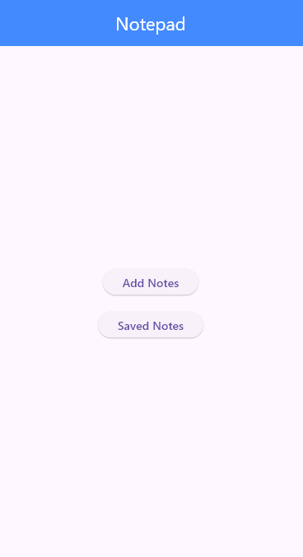
CODE
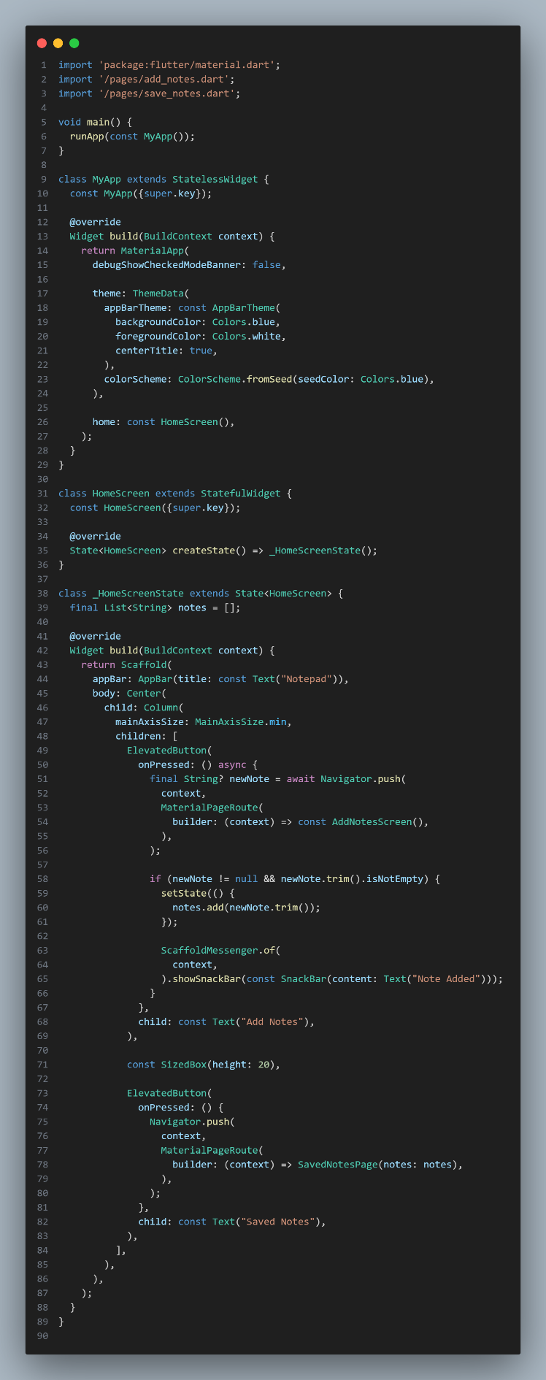
SCREENSHOT
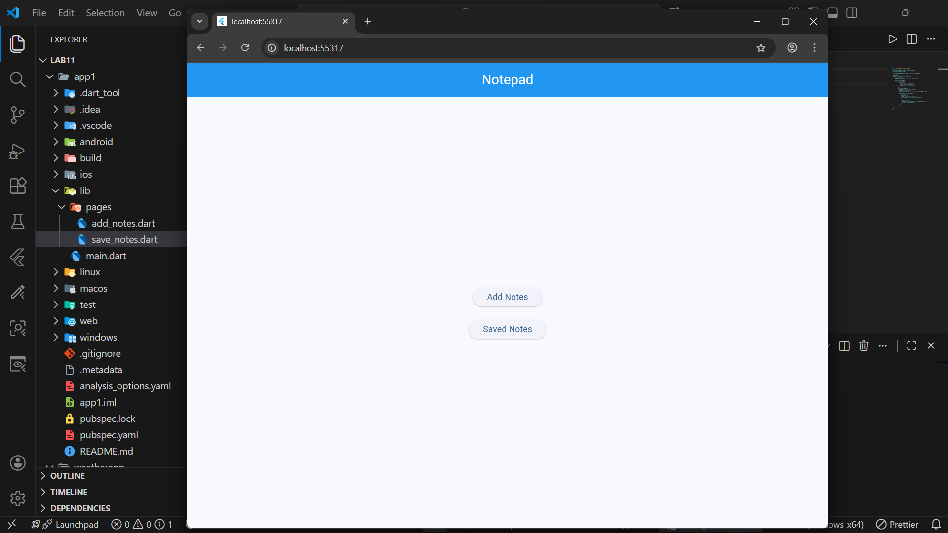

Task 3: Add Notes Screen
- By Clicking on Add notes on Home screen the user navigates to the Add Notes screen.
- Add an AppBar with Centered Text (Add Notes) and background color and Foreground Colors using themes
- Add text field on which user can add notes
- Add two buttons Add (Adds the notes) and Home (Going Back to home page)
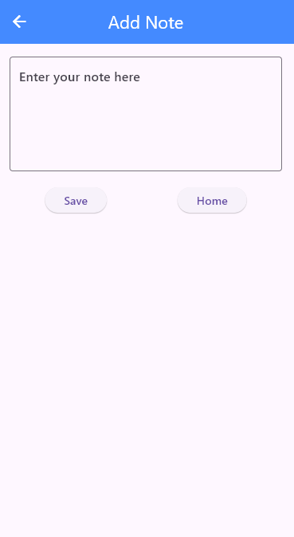

CODE
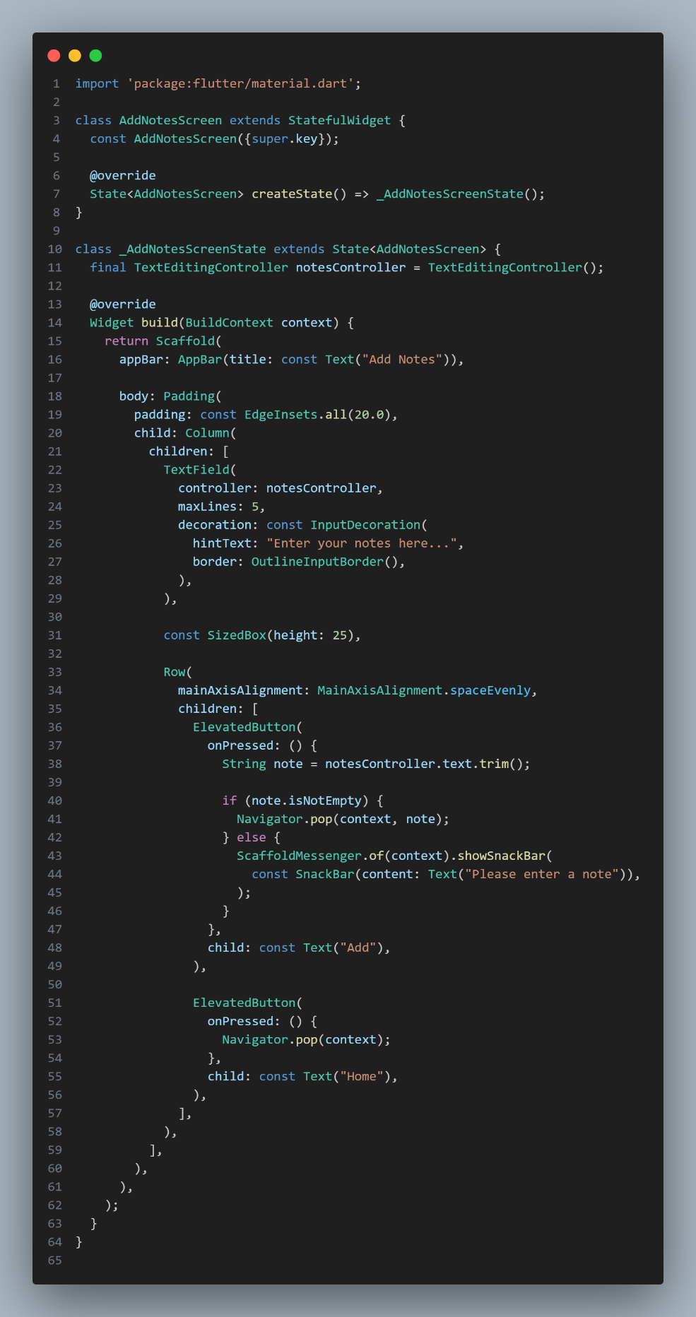
SCREENSHOT
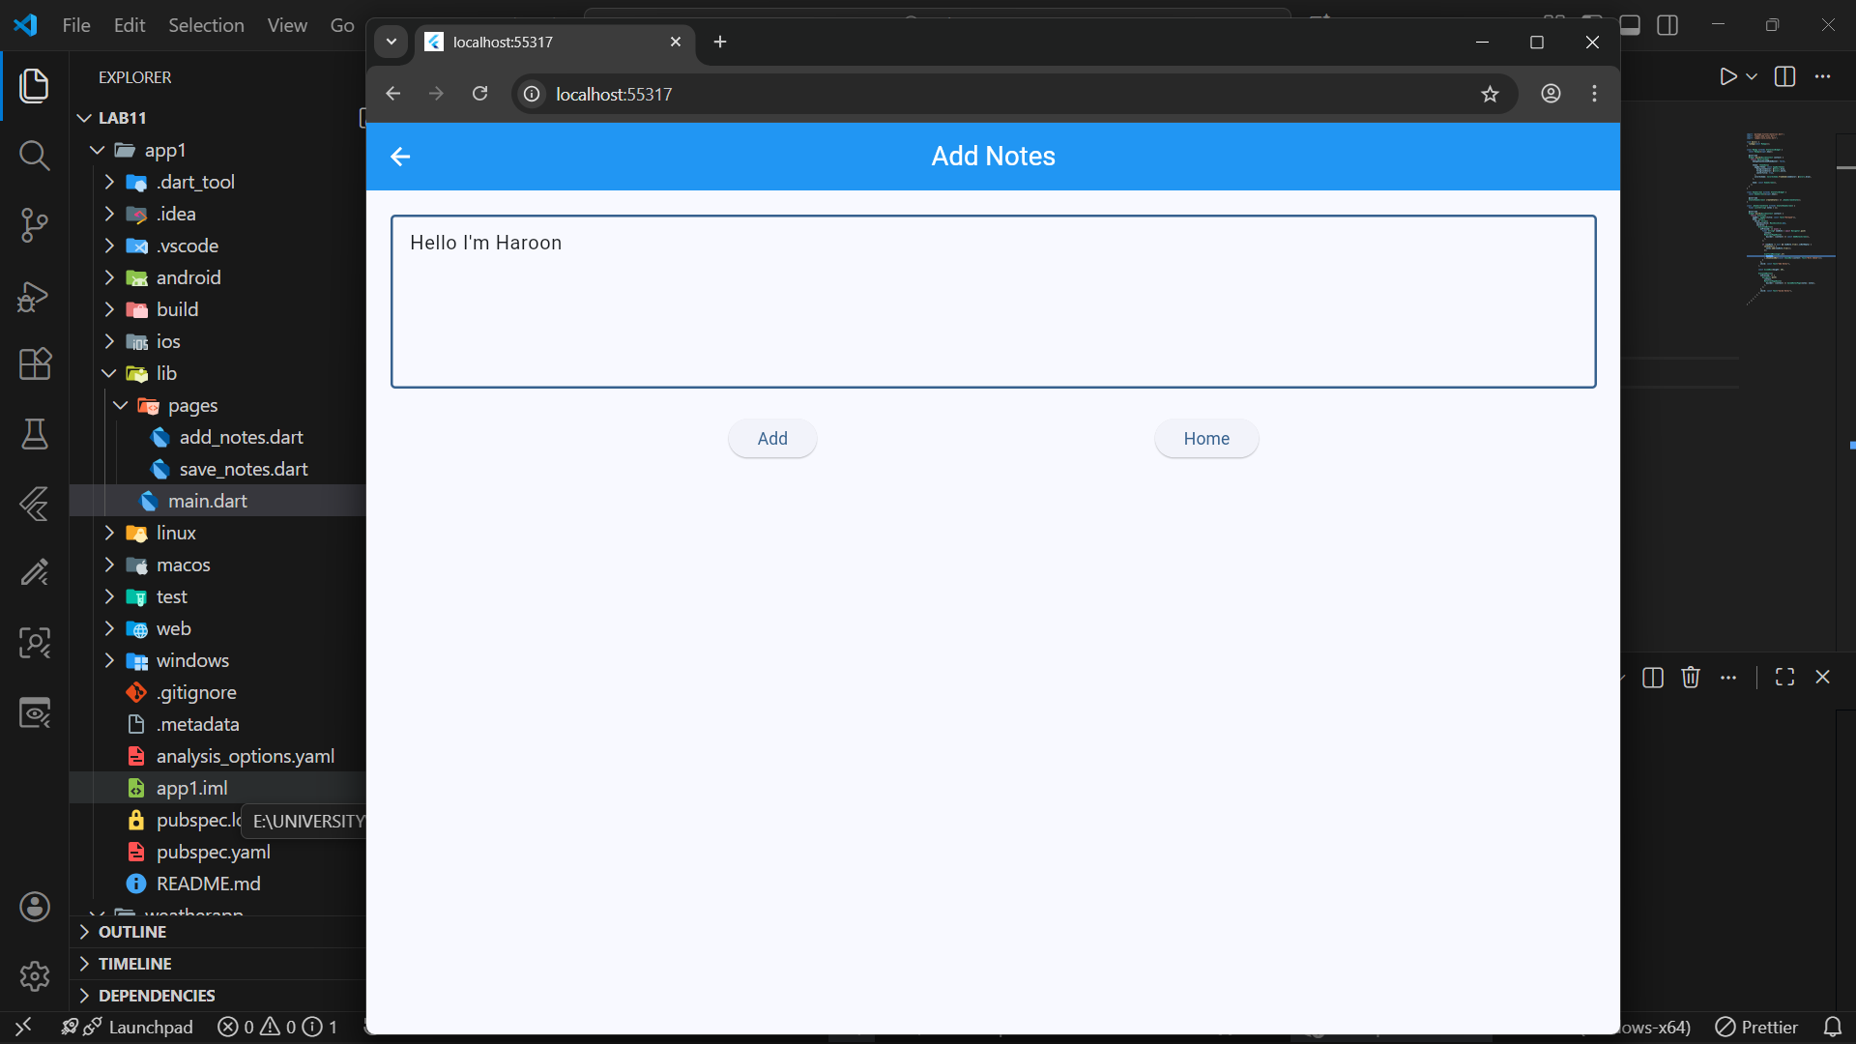

Task 4: Saved Notes Screen
- By Clicking on Saved notes on Home screen the user navigates to the Saved Notes screen.
- Add an AppBar with Centered Text (Saved Notes) and background color and Foreground Colors using themes
- The user should View the Notes Added by the user
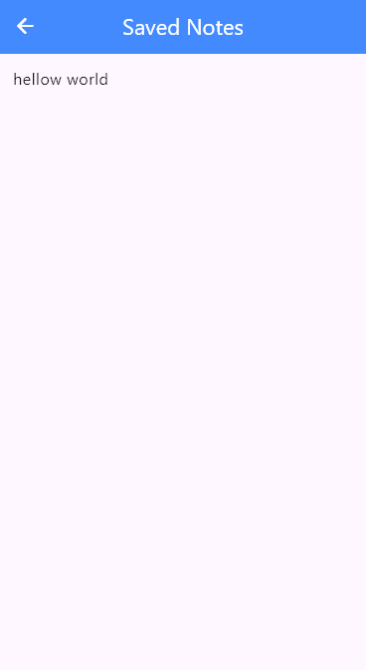

CODE
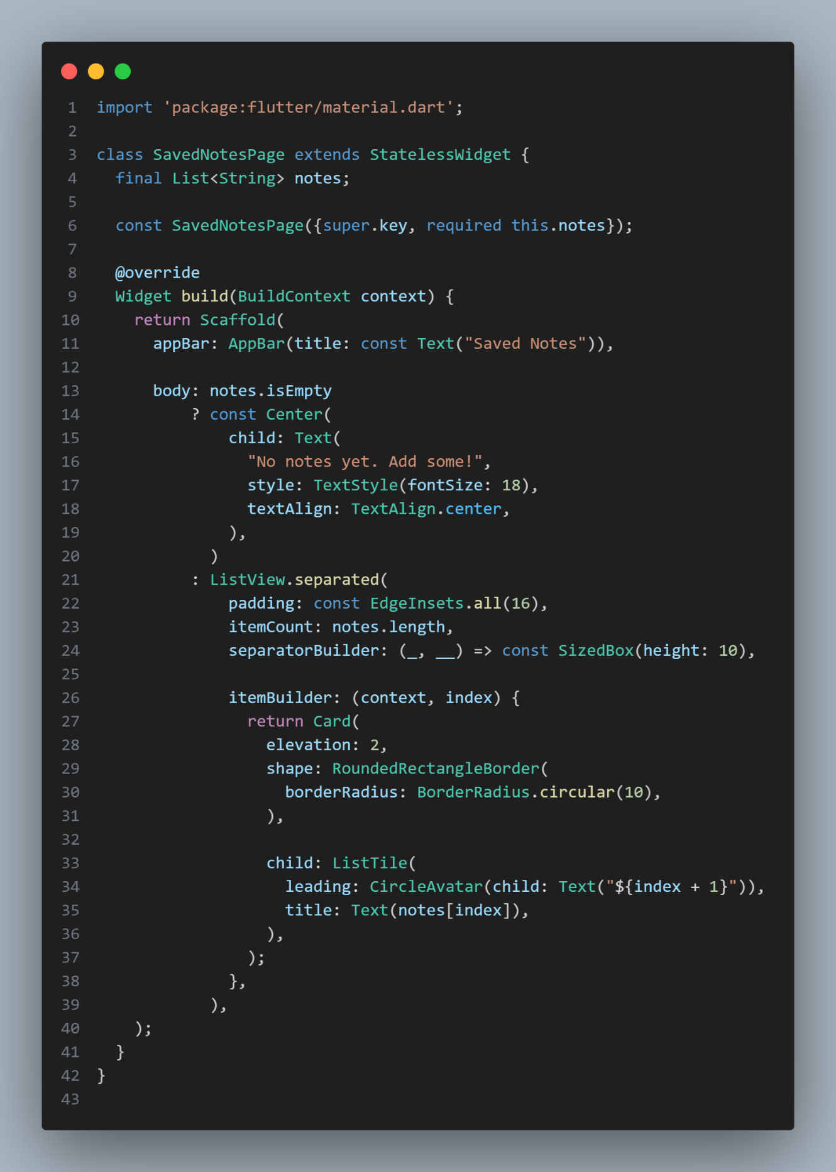
SCREENSHOT
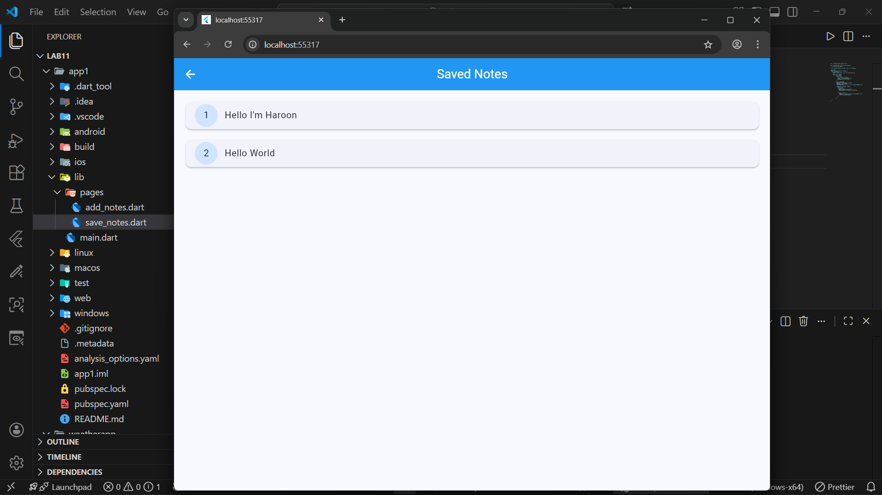

Task 5: Weather App
- Create an application the shows the Current Location in the form of longitude and latitude by using a geolocator class and also use Spin kit while the user is not allowed to access the location and Get the location and show it on the screen

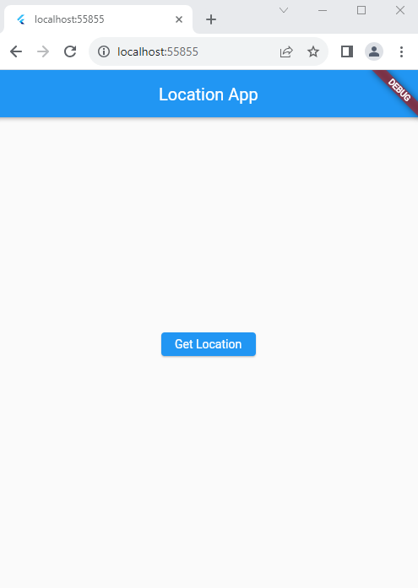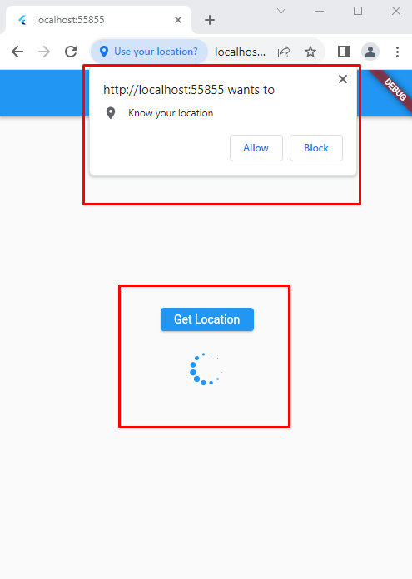

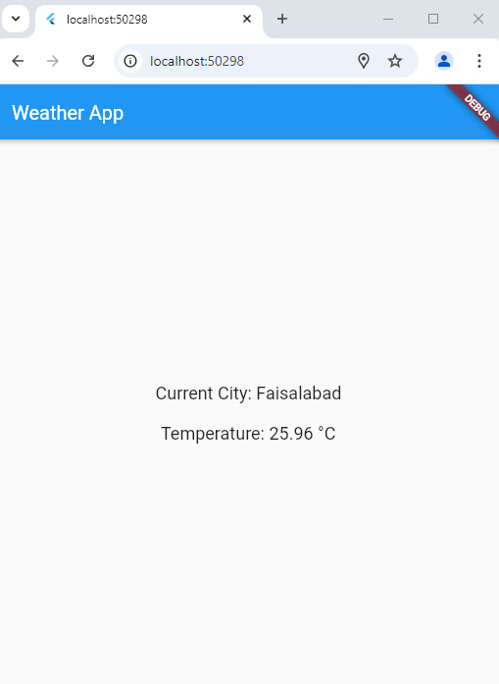

CODE
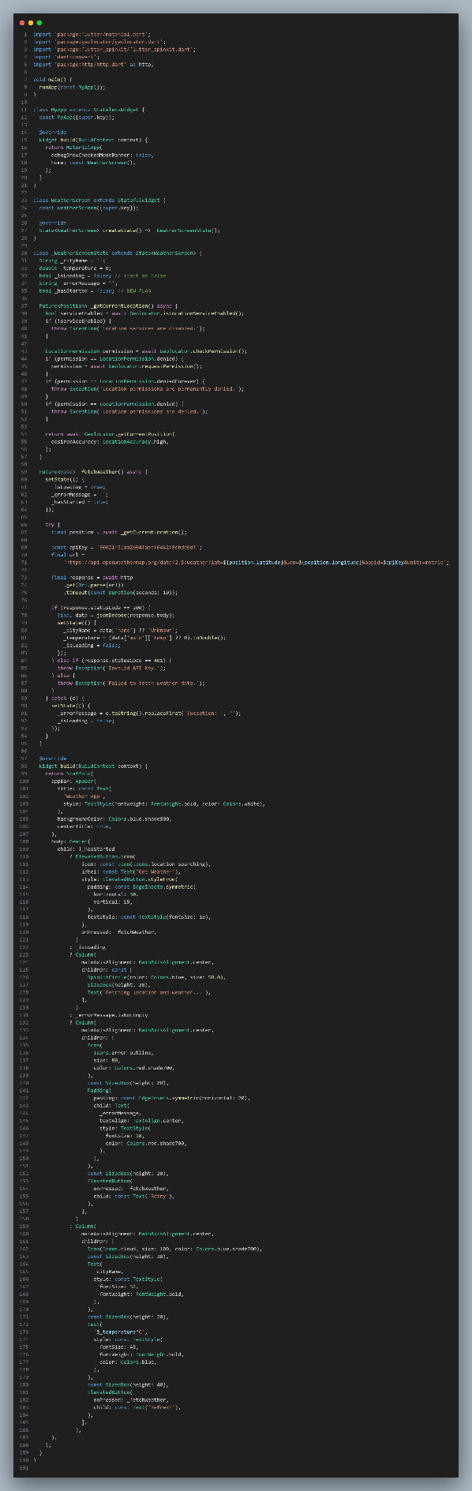
SCREENSHOT
